WHAT TO REVIEW IN A COURSE PROPOSAL

There are two types of course proposals: new courses and course changes.
A regular course will go through a full curricular review while other types of courses (blanket-numbered, special topics, experimental, and non-credit) will go through an expedited review process which has fewer reviewers. For minor changes to a course, such as changing the schedule type, crosslisting, or location, the review process also will be expedited.
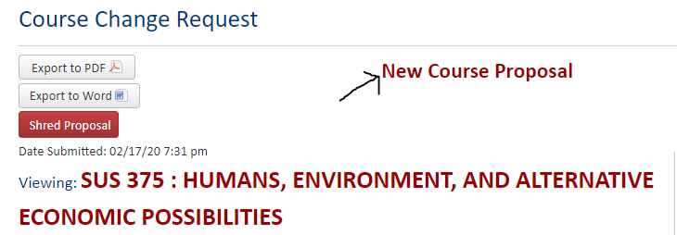
If you are reviewing a New Course proposal, you will see “New Course Proposal” at the top of the proposal.

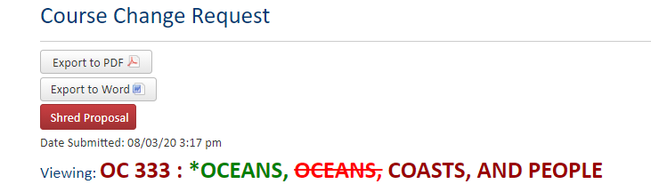
For a Course Change proposal, you will see text in red and green. Red text indicates the deleted content and green text indicates the added content.

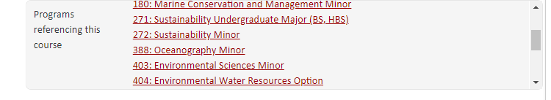
The CIM ecosystem pulls in course data from Banner as well as the Catalog. The ecosystem shows programs (majors, minors, options, or certificates) that require this course or use it as an elective. In addition, it lists courses that use this course as a prerequisite or equivalency.
Effective term refers to the term and year when the new course or changes to an existing course will be implemented. The Office of the Registrar will make the final determination based on the Catalog Year Policy.
The Justification is where the originator states why there is a need for the new course or the reason for the course change.
Primary Originators are the faculty or staff members in an academic unit/s who are responsible for the course proposal. Only the person who submits the proposal becomes part of the workflow and receives CIM notifications. Other people should be listed as primary originators if they are subject matter experts who can be contacted for more information.
Liaisons are academic units that can provide feedback on or may be impacted by the proposal. The Liaison Policy states that at least three liaisons are needed, two of which must come from outside the college of the originating academic unit. The remaining two liaisons can be from within the college but must be outside the originating academic unit.
Course Information
The Curriculum and Catalog Coordinators from the Curriculum Management office and OtR will make sure that the fields in this section are filled in correctly and aligned with the academic policies & regulations.
- Type of Course: The majority of OSU courses are regular courses. Blanket, Special Topics, Experimental, and Non-Credit are the other course types.
- Subject Code is also referred to as Course designator.
- The Course Level is either undergraduate or graduate. It is determined by the Course Number.
- The Classification of Instructional Programs (CIP) code is a national classification system for all majors, minors, options, certificates and courses. CIP codes are visible in Banner and are used for administrative purposes.
- Catalog Title is the long title and appears in the Catalog and Schedule of Classes.
- Transcript Title is the short title and appears in MyDegrees and on transcripts.
- College and Academic Unit refer to the administrative home of the course and where the primary instruction will be taught.
- A crosslisted course refers to a course with the same content, title, credits, description and prerequisites but offered under a different subject code.
- A slashlisted course is offered at both the undergraduate upper-division level (400-level) and graduate level (500-level).
- Schedule Type refers to the course delivery mode. Courses may include more than one schedule type. If a course will have a lecture, separate discussion sections, and/or laboratory sections, all three schedule types should be indicated for scheduling purpose.
- Course Credits: Most regular courses have fixed credits. If there is a laboratory/studio/recitation scheduled separately from the lecture, then the credits must be a range of '0 or XX' so students do not get double credit or double billed.
- Is this course repeatable for Credit? The majority of regular courses do not allow students to earn credits by repeating the course; however, there are some exceptions, such as studio-based courses like Music.
- The majority of courses use the 'Normal' grade mode of A-F. Most Blanket Numbered Courses use the 'Pass/No Pass' grade mode. The alternate Grade mode for A-F grade is Satisfactory/Unsatisfactory (S/U).
- Campus location is everywhere classes will be taught.
- Anticipated Scheduling is an estimate only. The unit can schedule classes in terms not included in the proposal, but for degree planning purposes it is useful to know when to expect the course will be taught.
- Programs Requiring this Course should include all the majors, minors, certificates and options where this course is listed as a program requirement. It is common for originators to leave this field blank because they don’t know the answer, which is fine since Banner and MyDegrees have that information.
- The primary purpose of the Course Description is to summarize course content and/or what students will be able to do effectively at the end of the course. It will be displayed in the Catalog. For consistency and ease of reading, the sentences should start with verbs such as examine, analyze, design, etc.
- The Major Transfer Map and Experiential Learning activities questions are for administrative purposes and should not be considered during review.

Course Relationship
As a reviewer, it is important to look at the appropriateness of this section.
- A prerequisite is a requirement, such as a course or placement test, that must be completed prior to registering for another course.
- A course that can only be taken at the same time as another course is considered a corequisite.
- Registration restrictions are rules at the section level that restrict registration to certain student populations as requested by department schedulers. For example, registration may be restricted to freshmen, a certain degree, or a specific program.
- Recommended courses are suggestions for courses students should take before enrolling in a specific course. This information will appear in the Catalog, but students are not required to take them.
- Equivalency refers to courses, possibly an earlier version of the course taught under a different title and number, that are similar enough to be considered the same. The grade repeat policy applies and students cannot get credit if they have already completed an equivalent course. This field is most commonly used for crosslisted courses and for courses that have been renumbered.
- The Baccalaureate Core component will be reviewed by the Baccalaureate Core Committee according to the criteria included on the Bacc Core Category Learning Outcomes webpage.

Learning Components.
As a reviewer, it is important to look at the appropriateness of this section.
- Student Learning Outcomes (LOs) reflect on what the students will be able to do as after completing this course. It’s important to ensure that the LOs are measurable and assessable. APA has provided guidelines on Bloom’s Taxonomy in the Syllabus Minimum Requirements. It is important to ensure that these Learning Outcomes are pitched at the right level of student learning (lower division, upper division, graduate level, etc). You will also see the graduate level LOs for a slashlisted course.
- Course Content lists the weekly schedule. When it is not possible for originators to list the weekly schedule, a concise outline of topics and activities covered in the course will be included.
- How Will Student Performance Be Evaluated details the grading breakdown of the course. It’s important to ensure that the assessments are aligned to the Learning Outcomes.
- Learning Resources lists all textbooks, reading materials, software, equipment, etc that the students will use in the course.
At the end of the proposal, you will see a course Syllabus attached and other optional supporting documents. APA will ensure that the syllabus has met the Syllabus Minimum Requirements.

Questions? Contact cim.help@oregonstate.edu

