HOW TO REVIEW A COURSE PROPOSAL
At OSU, multiple parties review and approve course proposals. With the exception of the liaison step, which is limited to 7 days days, review steps do not have a time limit. This means the proposal will not move forward until the current reviewer approves or sends it back. Only a reviewer assigned to the role and super administrators can act on the proposal. CIM will prevent anyone else from approving on their behalf.
To review a course proposal:
Step 1: When a course proposal reaches your queue, you will receive an email from CIM. Click on the link in box d shown below.
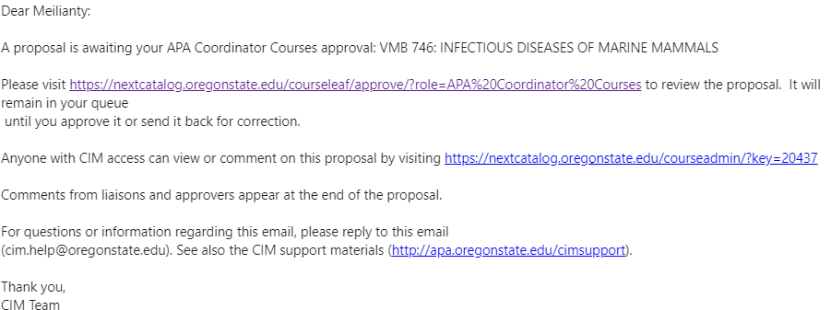
c
d
e
a
b

Legend
a: Your name
b: Your role. Note that some people may have more than one role.
c: Course title
d: Link to review the proposal – accessible only by the reviewer
e: Link to view the proposal – accessible by anyone who has CIM access.

Step 2: Enter your ONID username, password, and Duo authentication to log-in to CIM.

Once you have successfully logged-in, you will be directed to the Approval screen which looks like the one shown below.
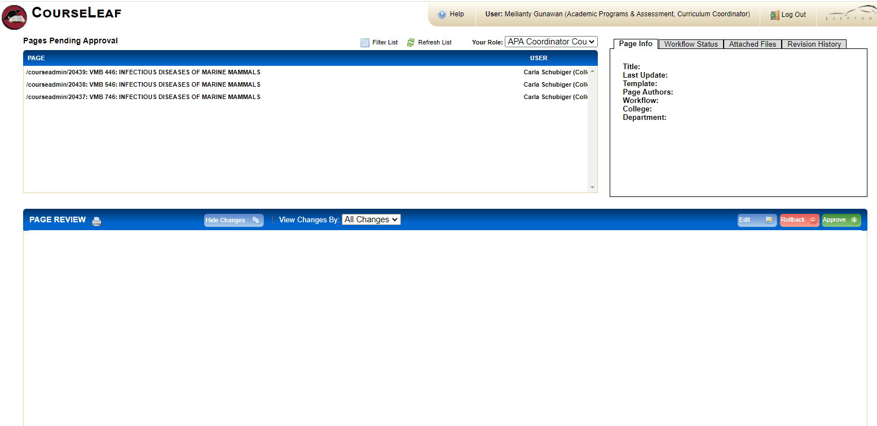
a
b
c

Legend
a: Drop-drown list of roles. Make sure you are in the correct role.
b: Proposals pending for your review
Proposal key number in CIM
Course Title
Course Number

c: Originator’s name

Note: If you accidentally lost the CIM email notification, go to https://nextcatalog.oregonstate.edu/courseleaf/approve/ to access the CIM approval screen.

Step 3: Click on a course to review. The course proposal form will be displayed as follows.
b
a
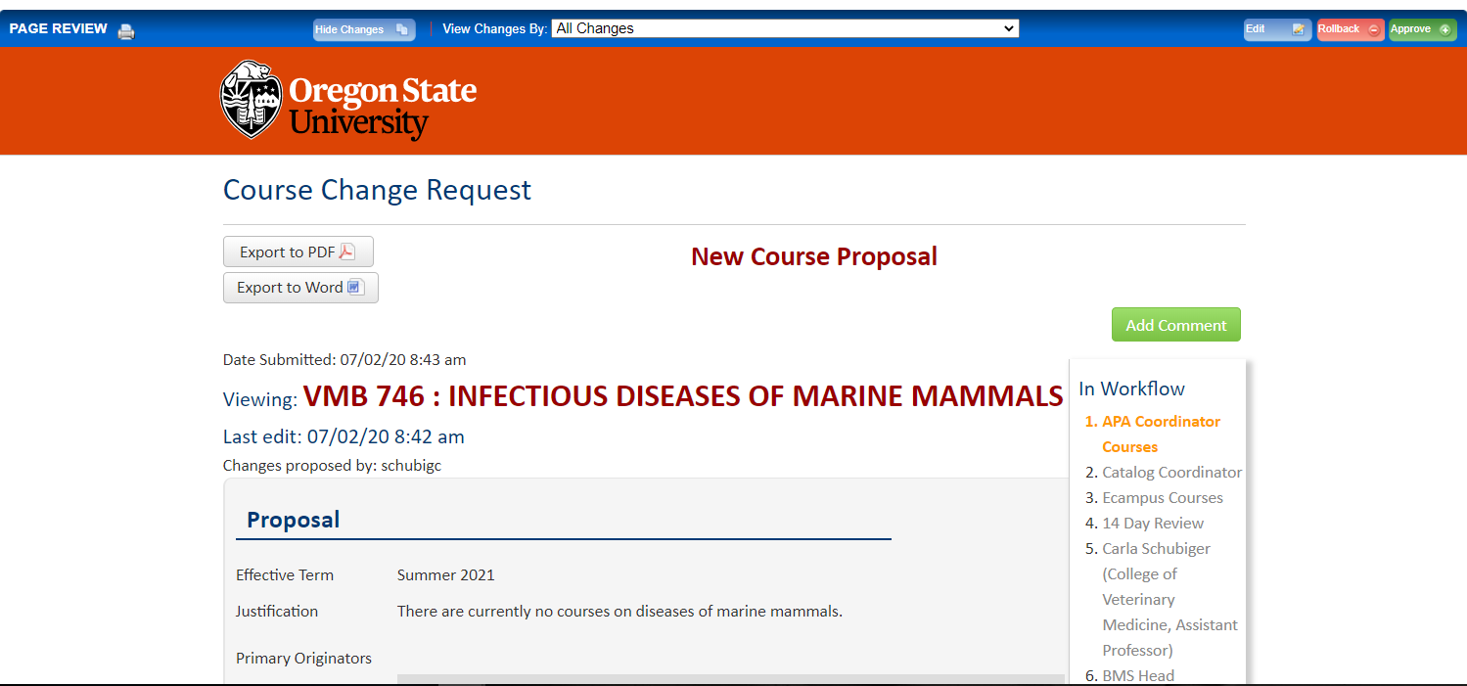

c
d

e

Legend
a: “View Changes By” box (drop-down list).
CIM tracks all changes made to the proposal by reviewers and the originator. By default, the box will be set as “All Changes”. The name of anyone who has edited the proposal will be shown in the drop-down list. The added and deleted text will be highlighted in green and red, respectively, in the proposal.
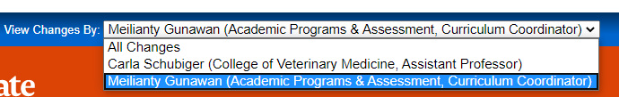

b: Action button
Edit: To make changes to the proposal. Use this sparingly with the consent of the originator.
Rollback: To return the proposal to the originator.
Approve: To move the proposal forward to the next reviewer

c: Indicator for a new course. This text doesn’t appear for a course change proposal.
d: Add Comment: To add a comment to the proposal.

e: Workflow path: List of reviewers*
Orange text: the approver whose review of the proposal is pending
Grey text: the approver next in workflow to review the proposal
Green text: the approvers who have completed their review of the proposal
*The list of reviewers will be customized by CIM depending on the type of course, its locations, and modalities.
Step 4: You have a choice of either returning or approving the proposal. Editing a proposal or adding a comment does not complete your role as a reviewer. Tip: Refer to “What’s Inside A Good Course Proposal” handout and video for insights into the reviewer role.
(a) Returning the proposal
Click the Rollback button.
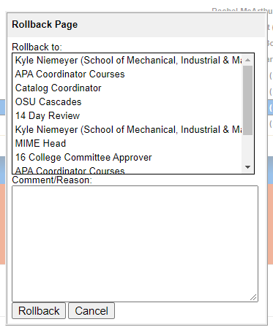
Depending on where your step is located in the workflow, you may see the originator’s name several times in the “Rollback to” box. Click carefully on the step you want to roll this proposal back to. You should roll back to the originator at the closest step to yours, rather than the first listing so that the workflow does not restart from the very beginning. For example, in the screen shot, the originator’s name appears twice. You should select the lower of the two listings of his name.
Enter your Comment/Reason in the empty box and click Rollback.

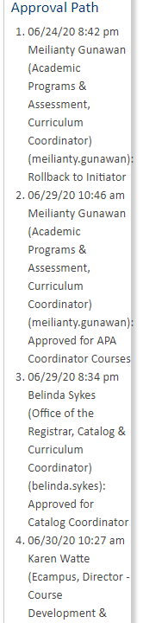
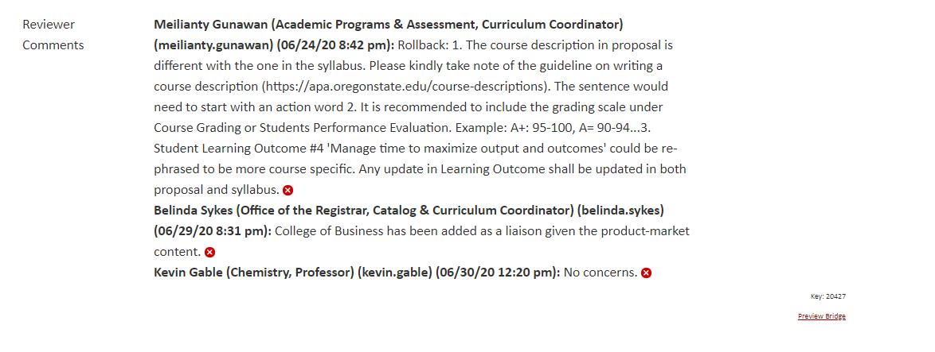
Your rollback comment will be captured in the Reviewer Comments trail at the bottom of the proposal form. In addition, a record of your rollback action will be captured in the Approval Path trail.

(b) Approving a proposal
Click the Approve button.
Your approval action will be captured in the Approval Path trail. The proposal will move forward to the next reviewer in the workflow.
To add a comment to the proposal, click the Add Comment button and save. Your comment will be captured in the Reviewer Comments trail at the end of the proposal.
A comment isn’t required; however, for Liaisons, it is highly recommended to add a comment to express your support or concern. For other reviewer roles, adding comment such as “Approved” or “Supported” is not necessary because you will click the “Approve” button.

Questions? Contact cim.help@oregonstate.edu

