Curriculum Inventory Management [CIM]
Quick Start Guide for Programs (Major, Certificate, Option, or Minor)

TO PROPOSE A CHANGE TO AN EXISTING PROGRAM:

- Go to https://nextcatalog.oregonstate.edu/programadmin/

2. Log on using your ONID username and your standard password. DUO is required.

3. In the field to the left of the Search button, enter the name of the course proposal (e.g., French*) you wish to edit and press the green Search button.

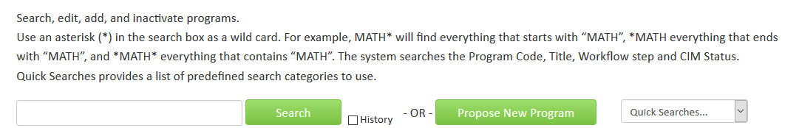

4. If there is a list of programs, click on the program you want to edit. If there is just one program, it already will be selected.

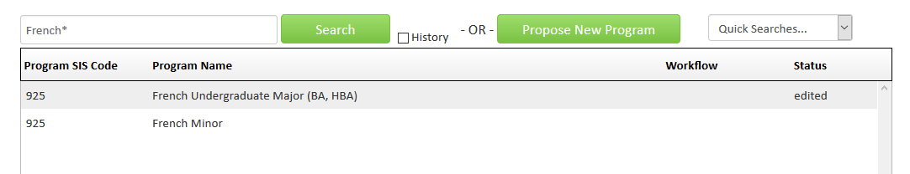

5. Review the field (Course Ecosystem) immediately below the program title. This area lists where the program appears in the academic catalog.

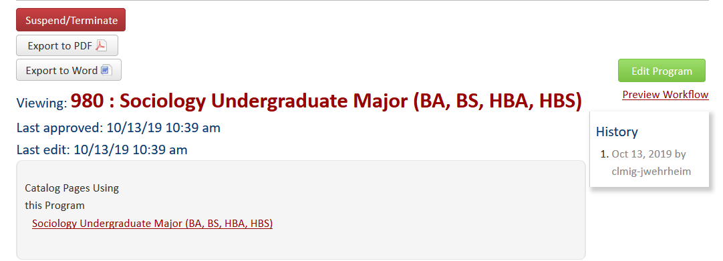
Course Ecosystem

- Click on the green Edit Program button to open the form.

Complete all required fields (outlined in red) before submitting your proposal. CIM forms are dynamic, so fields open and close based on selections you make early in the form. To save you time and effort, it is essential that you complete the following fields at the start of every program edit proposal:
- Program Level
- Program Type
- Type of Change

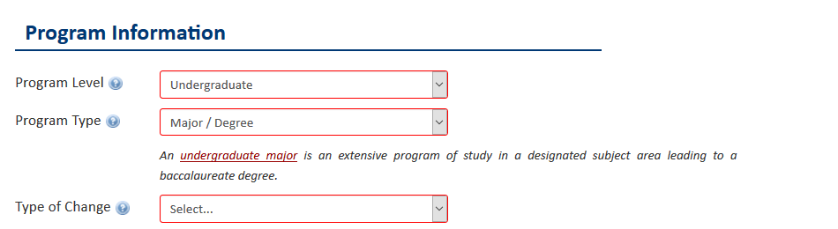

- Some types of changes require external letters of support and/or budget information. To upload these documents, click the appropriate green Attach File button. A Browse file box will open and you can select the file(s) to upload.
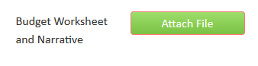

- To save the information you have entered, without submitting the proposal, scroll to the bottom of the form and press the Save Changes button. You can do this as often as you like.
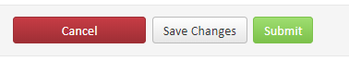

- Once your proposal is complete, press the green Submit button to enter it into workflow (start the review process).

Tips:
- Hover or click on help bubbles on the form for more information.
- Required fields are outlined in red.

Questions? Contact cim.help@oregonstate.edu

